Trace Viewer Manual

Trace Viewer is Palm OS application that allows you to take control of how the trace information, generated by calling the PmTraceLib* functions or the HsExtTrace* functions, is to be displayed, stored, and distributed. There are currently 2 flavors of this application – PmTraceViewer and HsTraceViewer. PmTraceViewer, whose application icon name is T.V.Pm, is used for trace information collected with the PmTraceLib* functions. HsTraceViewer, whose application icon name is T.V. Hs, on the other hand, is used for trace information collected with the HsExtTrace* functions.

This manual tries to explain all the different features of the Trace Viewer application. This document has information for developers and for QA on how and when to use the trace viewer to help them find or isolate a new bug. Despite the difference between their names, PmTraceViewer and HsTraceViewer have exactly the same user interface. Thus, this user manual applies to both.

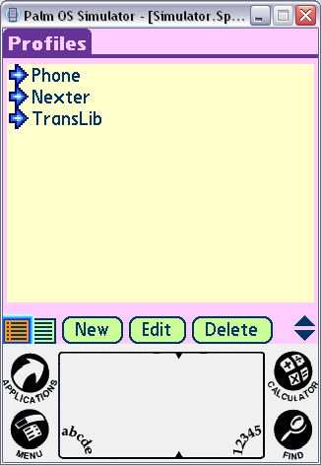

Above you can see the Profiles View of the Trace Viewer (TV) app. This is the first view you see after launching the Trace Viewer. In this view, you can create profiles of traces. A profile is a set of trace contexts that can be turned on together. Users can edit, delete and create new profiles. In addition a user can enable all the contexts contained by the profile by selecting the arrow to the left of the profile name. If we look at the Phone Profile above by selecting it and moving to the edit view, we can see which contexts are parts of the Phone Profile.

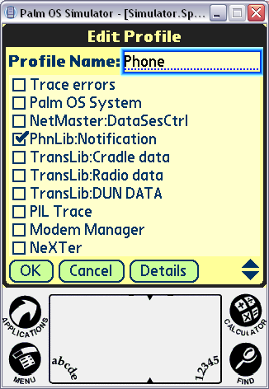

We can see from the view above that the Phone Profile contains the PhnLib contexts. Profiles can be defined by either QA or development and then shared with each other. You can export a profile to a SD card as a PDB file through the menu item “Actions | Export Profile to SD”. Others can then import the PDB file through the menu item “Actions | Import Profile from SD” or by hotsyncing the profile PDB to their device. This can be useful when trying to track down a bug. You can create a custom profile that will turn on the exact set of traces that are necessary to track down a particular bug. Once you understand that profiles contain contexts and you can turn profiles on, you might want to know which contexts are currently enabled and disabled. To find out the current state of any of the trace contexts, you can move to the Contexts view.

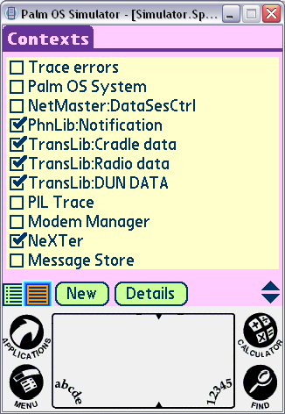

The figure above shows the Contexts view. This view lists all the contexts that are available to be enabled or disabled in the system. All the checked trrace contexts are enabled, while the others are disabled. From the figure above you can see that all the PhnLib, TransLib and NeXTer contexts are enabled. These contexts were all enabled by enabling the Phone, TransLib and Nexter profiles, when writing this manual, by click on the arrow next to the profile names in the Profiles view. From this Contexts view as above, you can check and uncheck the checkbox to change the state of any single trace context. For example if you uncheck the checkbox of PhnLib:Notification, then you will disable that trace context.

For Developers Only:
You can turn on and off any specific trace level by touching the name of the trace context. When you touch the name of the trace context, you get a trace context details dialog.
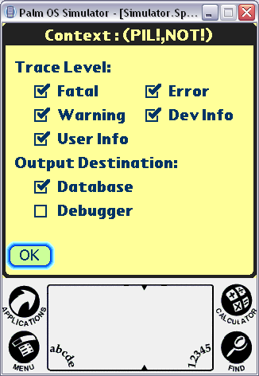
In this dialog, you can enable any single trace level. In addition, you can turn on the debugger trace output destination. This is useful when you are doing development. If you turn on the debugger output destination, all your traces will be dumped to the debugger real time. You can use this facility to allow you to view DbgMessage style runtime trace messages. Also notice that the component ID and subcomponent ID are in the title of the dialog.

Now that we understand the basics of profiles and contexts, I will discuss the menu items and how/when to use each item. There are three main menus; Actions, Output and Options. The Actions menu contains items that let you act now on the current set of traces and import/export the profiles.

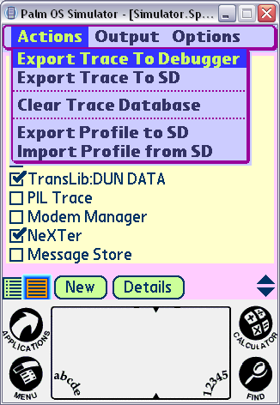

The Export Trace To Debugger option dumps all the traces in the trace database to the Palm Debugger. It dumps all the data in XML or non-XML format, depending on your choice in the dialog invoked with the Debugger Export Options menu item, and can then be cut and paste into an email or saved using a text editor. The Export Trace To SD option saves the current trace database to the SD card in XML text, non-XML text, or raw PDB format, depending on your choice in the dialog invoked with the SD Export Options menu item. It will be named with the current date and time. You can use this if you are not near a PC and want to save the trace information so that you can send it later to the developer. This action of exporting to SD does NOT clear the trace database.

The Clear Trace Database menu item clears the trace database. You usually want to do this when you are getting ready to reproduce and bug and want to start with a clean set of traces.

The Export Profile to SD menu item brings up a dialog that allows you to export a profile to a SD card. The profile will be saved on the SD card under the “Profiles” folder as PDB files.

The Import Profile from SD menu item brings up a dialog that allows you to import a profile from a SD card. You can enable and disable the profile once it is imported to your device.

Besides importing using the Import Profile from SD menu item, you can also simply HotSync a profile PDB file to your device. The profile will show up in the Profiles view automatically once PDB file is on your device.

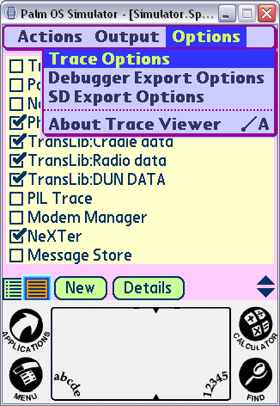

The Options Menu provides options for the actions in the actions menu. The Trace Options menu item allows you to set the size of the trace database. By default the size of the trace database is “Large”. You can change the size of the database to match the length of time it takes to reproduce a given bug.

Tiny = 10 traces (Only should be used when you are shipping)
Small = 4*1024 traces
Medium = 10 * 1024 traces
Large = 20*1024 traces

The Debugger Export options allow you to specify whether to export in XML format and which parts of each trace you want exported to the debugger. By default, all but the date is exported to the debugger in non-XML format. In some cases you might want less or more information in the debugger traces. Usually this will not be changed by QA but instead will be used by developers to fine tune the trace output during development.

The SD Export Options allow you to set an interval for when the trace database should be moved to the SD card . This can be useful because in general traces tend to grow large over time but you might not want to delete all the traces that you have gathered so far. Therefore, you enter a minute interval for when you want the trace database to be moved over to the SD card. Each trace database stored on your SD Card is named Trace Database.<date>.<time>. The date and time are filled in dynamically. Notice that the trace database is moved not copied to the SD card. In other words, at the end of each interval the trace database on the device is copied to the SD Card and then cleared.

The SD Export Options also allow you to choose to export the trace database in non-XML text, XML text, or raw PDB format. The Trace Viewer application needs to do extra work and thus takes longer to export in non-XML text and XML text formats. Therefore, if you have a large amount of data in the trace database, you may want to choose the raw PDB format.

